EXP. NO. 1

WEB PAGE CREATION USING HTML AND CSS WITH FRAMES, HOTSPOTS AND LINKS

AIM:
To create a web page that embeds a map with hotspots, frames, and links. The web page should be designed using HTML, incorporating embedded, external, and inline CSS for styling. This exercise aims to enhance understanding of integrating multimedia elements like maps, creating interactive hotspots, and organizing content using frames while applying different CSS techniques for styling.

ALGORITHM:

Create the HTML structure:
- Set up the basic HTML document with <!DOCTYPE html>, <html>, <head>, and
<body> tags.
- In the <head>, link the external CSS file (<link> tag), define the title, and include any metadata.
- In the <body>, create the necessary elements:
  - Frames: Use the <frameset> tag to create a frame layout (for older browsers, use <iframe> instead).
  - Map: Use the <img> tag to display a map.
  - Hotspots: Create clickable regions using the <map> and <area> tags.
  - Links: Add hyperlinks (<a>) to navigate to different parts of the page or external sites.

Create CSS Styles:
- External CSS: In a separate file, define styles such as colors, fonts, and layout for the entire page.
- Inline CSS: Use the style attribute within specific tags to apply styles (e.g., in <div> or <p> tags).
- Embedded CSS: Inside the <style> tag in the <head>, define styles for specific elements like the map, frames, and text.

Map with Hotspots:
- Use the <map> tag to create an image map.
Define the <area> tag for each hotspot, specifying the coordinates (e.g., coords="x,y,x2,y2") for clickable areas on the map
FRAMES:
- Use the <iframe> tag for embedding external content like a map or another webpage, with attributes such as src for the URL, width, and height.

Add Links:
- Inside the <body>, use the <a> tag to create links for navigation (for example, to link to specific parts of the page or external sites).

Test the Page:
- Test the webpage to check the functionality of frames, hotspots, and links. Ensure that the map hotspots are clickable and the linked content displays correctly.
- Ensure that the styles are applied properly using inline, embedded, and external CSS.
CODE:
<!-- =========================
FILE 1: index.html
========================= -->
<!DOCTYPE html>
<html lang="en">
<head>
<meta charset="UTF-8">
<meta name="viewport" content="width=device-width, initial-scale=1.0">
<title>Expense Tracker Web App</title>

<!-- External CSS -->
<link rel="stylesheet" href="style.css">

<!-- Embedded CSS -->
<style>
h1 {
color: darkblue;
text-align: center;
}

iframe {
border: 3px solid black;
border-radius: 10px;
}
</style>
</head>
<body>

<!-- Inline CSS -->
<h1 style="background-color: lightyellow; padding: 10px;">
Expense Tracker Web Application
</h1>

<!-- Navigation Links -->
<div class="nav">
<a href="#tracker">Expense Tracker</a>
<a href="#map">Location Map</a>
<a href="#frame">Frame Example</a>
</div>

<!-- Expense Tracker Section -->
<section id="tracker" class="container">
<h2>Add Expense</h2>

<form id="expense-form">
<input type="text" id="title" placeholder="Expense Title" required>

<input type="number" id="amount" placeholder="Amount" required>

<button type="submit">Add Expense</button>
</form>

<h3>Total Expense: ₹<span id="total">0</span></h3>

<ul id="expense-list"></ul>
</section>

<!-- Map Section -->
<section id="map" class="container">
<h2>Embedded Google Map</h2>

<!-- Embedded Map -->
<iframe
src="https://www.google.com/maps/embed?pb=!1m18!1m12!1m3!1d3916.2054379628627!2d76.9558!3d11.0168!2m3!1f0!2f0!3f0!3m2!1i1024!2i768!4f13.1!3m3!1m2!1s0x3ba859b3e0f7c8e7%3A0x7b7f8c6c8e2c2f3!2sCoimbatore!5e0!3m2!1sen!2sin!4v1690000000000"
width="100%"
height="300"
allowfullscreen=""
loading="lazy">
</iframe>

<!-- Image Map / Hotspot -->
<h3>Image Hotspot Example</h3>

<img src="https://via.placeholder.com/500x250"
usemap="#hotspotmap"
alt="Hotspot Example">

<map name="hotspotmap">
<area shape="rect"
coords="50,50,200,150"
href="https://www.google.com"
alt="Google"
target="_blank">

<area shape="circle"
coords="350,120,50"
href="https://www.youtube.com"
alt="YouTube"
target="_blank">
</map>
</section>

<!-- Frame Section -->
<section id="frame" class="container">
<h2>Frame Example</h2>

<iframe src="https://www.wikipedia.org"
width="100%"
height="300">
</iframe>
</section>

<script>
// Expense Tracker JavaScript

const form = document.getElementById("expense-form");
const title = document.getElementById("title");
const amount = document.getElementById("amount");
const expenseList = document.getElementById("expense-list");
const total = document.getElementById("total");

let totalExpense = 0;

form.addEventListener("submit", function(e) {
e.preventDefault();

const expenseTitle = title.value;
const expenseAmount = Number(amount.value);

// Create list item
const li = document.createElement("li");
li.innerHTML = `${expenseTitle} - ₹${expenseAmount}`;

expenseList.appendChild(li);

// Update total
totalExpense += expenseAmount;
total.textContent = totalExpense;

// Clear inputs
title.value = "";
amount.value = "";
});
</script>

</body>
</html>

OUTPUT:
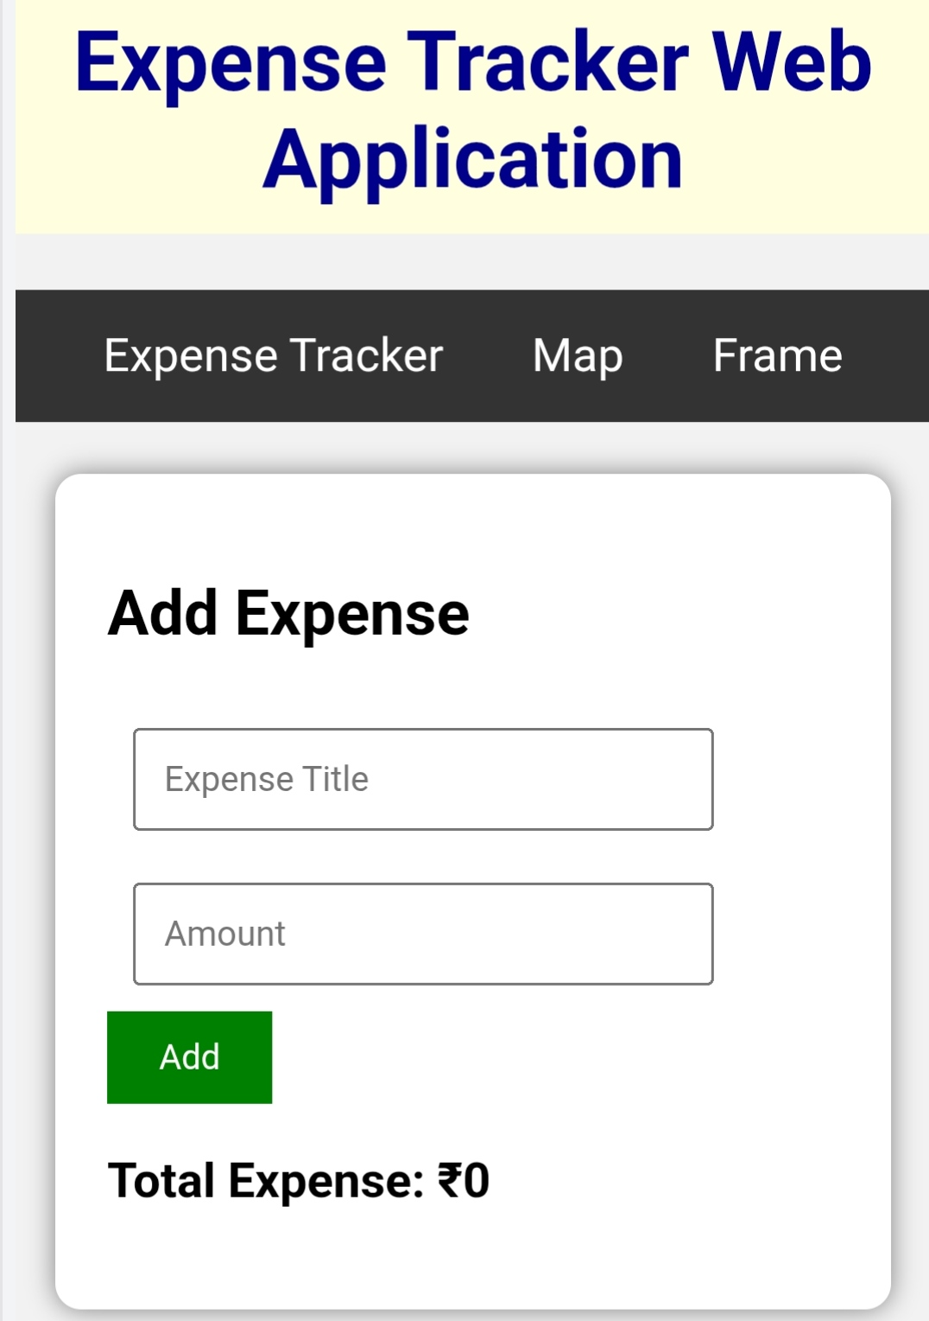
RESULT:
Html Page is created with embedded map along with hot spot, frames &
links.

